Add your Title here

Surname Name 1,*, Surname Name 2, and Surname Name 1

1*Add Adress here,* *Add Adress here,* *Add Adress here,* *Add Adress here,* *Add Adress here,* *Add Adress here,* *Add Adress here,* *Add Adress here,* *Country*

2*Add Adress here,* *Add Adress here,* *Add Adress here,* *Add Adress here,* *Add Adress here,* *Add Adress here,* *Add Adress here,* *Add Adress here,* *Country*

**Abstract**: Please be limited to the abstract and the Graphical Abstract in the first page of your paper. The introduction should appear in the second page. The papers published in the proceedings of the JSI’2024 will be evaluated by the scientific committee. The selected and presented papers will be published in a Book and/or proposed International Journals. Your paper should be submitted via the Conference Web site:

<https://www.jsi-conference.tn/>

If there is any inquiry, please contact us via email: [conference.jsi@gmail.com](mailto:conference.jsi@gmail.com)

**Keywords:** Rarefied flow; porous media; transition regime; Direct Simulation Monte Carlo; Lattice-Boltzmann; mesoscopic methods.

. 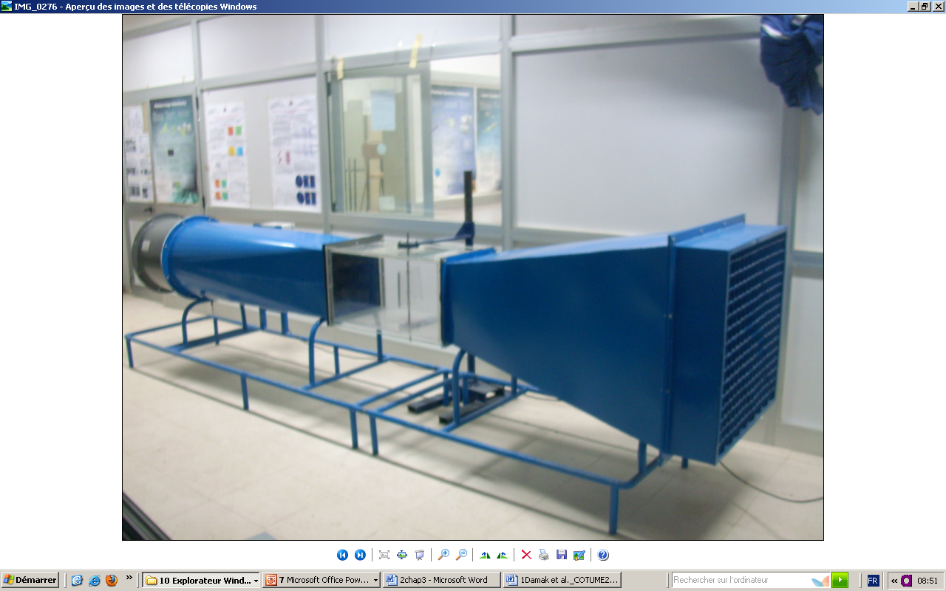

**Graphical abstract**

INTRODUCTION

Recent advances in microtechnology and, in particular, in microelectromechanical systems (MEMS) and nano porous media have necessitated the elucidation of flow and transport processes in small dimensions. This is also the case with several other industrial applications, which rely on low-pressure conditions, or

the molecular time and length scales are not sufficiently small compared to the characteristic macroscopic flow scales.

The various flow regimes and the corresponding governing equations are summarized in Fig. 1 (see also [1]).

For the titles, please use these formats:

Title 1 (First style)

Subtitle (second style)

*Subtitle (Third style)*



**Figure 1:** Flow regimes and governing equations.

In the context of this work a description of recent advances in simulation techniques, namely, the “continuum” slip approaches [1, 9], and direct mesoscopic techniques, such as the Direct Simulation Monte Carlo (DSMC) method [8, 10-12], the Information Preservation (IP) method [13-16], and the Lattice Bolzmann (LB) method [17-18], are presented. Illustrative simulation results of permeability and viscosity coefficients in mesoporous media using the

 ()

Following eq. (1.), the Knudsen number can be expressed as

 ()

where  is a characteristic macroscopic flow dimension.

Several methods to simulate rarefied flows have been proposed, which fall into two main categories, namely macroscopic and microscopic approaches. The former consist of the direct solution of the Navier-Stokes equation or semi-empirical equations with appropriate boundary condition to induce the slip effect, whereas the latter consist of either direct or stochastic particle monitoring methods using kinetic theory descriptions, such as Molecular Dynamics (MD) and Monte Carlo (MC) methods. Even though the microscopic approaches are more accurate inherently, most processes involving porous media and micro-sized devices (*i.e.* MEMS) would require enormous CPU resources to be simulated effectively.

Strictly, the continuum condition (Fig. **1**) prohibits the use of the Navier-Stokes equation for non-zero Knudsen numbers. Nevertheless, by introducing slip boundary conditions, Arkilic and coworkers [9] proposed a two-dimensional scheme for rarefied flows involving the Navier-Stokes equation and a first order boundary condition, proposed by Maxwell [2] (Fig. **2**), which reads

 ()



**Figure 2:** Slip velocity at the wall.

**Table 1:** Thermo physical properties.

|  |  |  |
| --- | --- | --- |
|  | T (°C) | Cp (kJ.kg-1.K-1) |
| Water | 25 | 4.18 103 |
| Air | 25 | 1.01 103 |

. ()

The authors [12] further simplified the boundary condition in order to avoid the calculation of the 2nd order velocity derivatives that may introduce computational difficulties, to the following slip boundary condition

, ()

where *b* is a parameter that “incorporates” the 2nd order derivative term and takes the value *b* =-1 for fully developed flow in a channel.

CONCLUsions

The need to describe rarefied flows in a variety of applications that involve micro, and nanoscale pores or channels has stimulated the development of a multitude of theoretical and numerical methodologies. A comparison of the predictions of the mesoscopic approaches with those of the Navier-Stokes formulation complemented by a non-slip flow condition revealed that the latter can be safely employed for very small Knudsen number values only. The DSMC method was used to determine the flow field in different types of porous media and processes.

Conflict of Interest

To be declare if it is required

Acknowledgement

To be declare if it is required

REFERENCES

[1] Anderson SJ, Lenburg M, Landau NR, Garcia JV. The cytoplasmic domain of CD4 is sufficient for its down-regulation from the cell surface by human immunodeficiency virus type 1 Nef. J Virol 1994; 68: 3092-01.

[2] Banda NK, Bernier J, Kurahara DK, et al. Crosslinking CD4 by human immunodeficiency virus gp120 primes T cells for activation induced apoptosis. J Exp Med 1992; 176: 1099-06.

[3] Watkins JC. Twenty-five Years of Excitatory Amino Acid Research. In: Roberts PJ, Storm-Mathisen J, Bradford H, Eds. Excitatory Amino Acids. Chichester, MacMillan Press, 1986; pp. 1-39.

[4] O’ connor CC, Wen LM, Rissel CE, Shaw M. Sexual Behaviour and Risk in Vietnamese Men living in Metropolitan Sydney. Sex Transm Infect. Sydney, Australia 2006.

[5] Crandell KA, Ed. The Evolution of HIV. Baltimore: Johns Hopkins Press 1999; pp. 3-4.

[6] Schleyer TK, Teasley SD, Bhatnagar R. Comparative case study of two biomedical research collaboratories, Los Angeles, California: USA 2001; pp. 166-9.

[7] Ippolito G, Comandini VU, Nicastri E. The legal proceeding on the use of genotypic assays for the detection of HIV antiretroviral resistance, National Institute for Infectious Diseases, Rome: Italy 2003

[8] Diana MG, Sandra EMD, Ramyani G, Pat AT, Catherine SP. Factors affecting uptake of antenatal HIV testing in London: Result of multicentre study 1998. BMJ [serial on the Internet]. 1998 Jan 24. Available from: <http://www.bmj.com/cgi/content/full/316/7127/259>